**Wireless and Mobile Communication**

**Practical 4**: **Doppler Spread and Delay Spread**

**Date: 21/02/2022**

**Aim:** To study and observe the effect of Doppler spread and delay spread for fast fading and slow fading channels and calculate the coherent bandwidth in Matlab.

**Software:** MATLAB

**Theory:**

**Multiple access techniques**

Multiple access techniques are used to allow a large number of mobile users to share the allocated spectrum in the most efficient manner. As the spectrum is limited, so the sharing is required to increase the capacity of cell or over a geographical area by allowing the available bandwidth to be used at the same time by different users. And this must be done in a way such that the quality of service doesn’t degrade within the existing users.

A cellular system divides any given area into cells where a mobile unit in each cell communicates with a base station. The main aim in the cellular system design is to be able to increase the capacity of the channel i.e. to handle as many calls as possible in a given bandwidth with a sufficient level of quality of service.

These includes mainly the following:

* Frequency division multiple-access (FDMA)
* Time division multiple-access (TDMA)
* Code division multiple-access (CDMA)

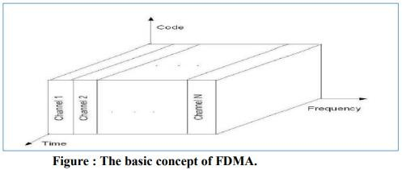

1. Each individual user is assigned a pair of frequencies while making or receiving a call as shown in Figure. One frequency is used for downlink and one pair for uplink. This is called frequency division duplexing (FDD).

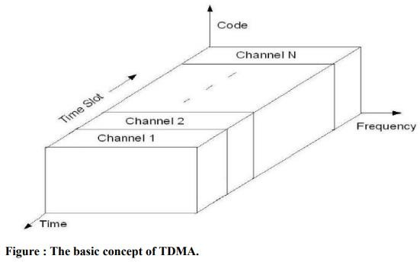

1. In digital systems, continuous transmission is not required because users do not use the allotted bandwidth all the time. In such cases, TDMA is a complimentary access technique to FDMA. Global Systems for Mobile communications (GSM) uses the TDMA technique.

In TDMA, the entire bandwidth is available to the user but only for a finite period of time. The users are allotted time slots during which they have the entire channel bandwidth at their disposal, as shown in Figure

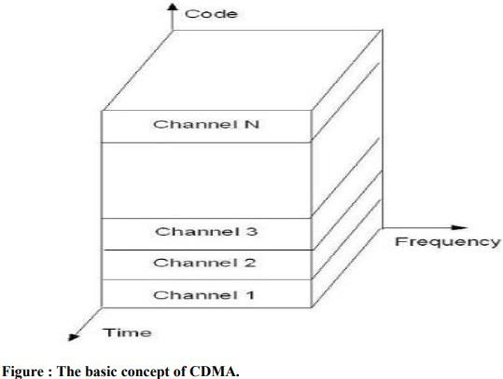

1. In CDMA, the same bandwidth is occupied by all the users, however they are all assigned separate codes, which differentiates them from each other shown in Figure

CDMA utilize a spread spectrum technique in which a spreading signal (which is uncorrelated to the signal and has a large bandwidth) is used to spread the narrow band message signal.

**Direct Sequence Spread Spectrum (DSSS)**

In DS-SS, the message signal is multiplied by a Pseudo Random Noise Code.

Each user is given his own codeword which is orthogonal to the codes of other users and in order to detect the user, the receiver must know the codeword used by the transmitter.

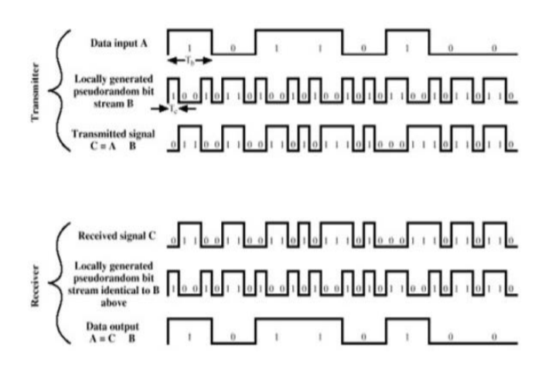

# **Algorithm:**

**PART 1**

* Generate a binary message signal using **rand** function. Take size as (1000,1) initially and later change it as per (1XXX,1), where XXX is your three digit roll No.
* Generate a PN sequence using **commsrc.pn** from communication system tool box of MATLAB.
* Expand the message bit using **repmat**, so as to make it of size [1000, 8]
* Xor(msg, pn) size[1000,8]:
* Convert the vector into row vector: **Spreaded data [8000, 1]**
* Change the binary data into uint8 before modulation
* Choose mod=4, QPSK/QAM
* Add awgn for a single value of SNR
* Demodulate the signal using qamdemod /pskdemod
* Using reshape, convert the serial demodulated data vector to parallel before despreading. [1000, 8]
* Despread the signal by using xor function despread_data= xor(demod_data, pn)
* Contract the data to original format by
* msg_rx=round(mean(despread_data,1)); mean(x,1)🡪row vector mean(x,2)🡪column vector
* Example: [1 0 1 1 1 1 1 1] = 7/8 =0.875
* Calculate the BER
  + BER=mean(abs(msg_rx-msg));
  + This is for a single value or SNR.
* Now, vary SNR [-10:1:10]
  + Plot BER vs SNR
  + Output plots [choose msg bits=4]
* Msg signal
* PN sequence
* Spreaded data
* Modulated signal
* Demodulated signal
* Despreaded signal
* Received message signal
* SNR versus BER plot [msg bits=1000]

**PART 2**

* Choose 3 different message signals of same length using rand function.
* Allocate three PN sequence for each message signal.
* Perform spreading, modulation, demodulation, despreading same as in Part-I for three messages and three
* PN sequence.
* Plot BER vs SNR for three messages.

**Code:**

**Part 1:**

**Result:**

### **Fast Fading Doppler Spread:**

### **Slow Fading Doppler Spread:**

1. **Delay Spread**

**Calculation:**

**Conclusion:**